Group - 7

Controlling My Houses

|  |  |  |  |  |
| --- | --- | --- | --- | --- |
| Team: |  | Sanket S Kale  Rutuja Nikam  Sajjad Hashmani  Rohit Katta  Ilwin Dcunha |  |  |

GA1

CONTROLLING MY HOUSES

Group Number: 7

Project Name: Controlling My Houses

Universe of Discourse(UoD) --- The scope of the project is the user of the website and the houses that he owns. It focuses on the expenses made and the amount earned through these owned houses.

Purpose of the project: In today’s time the real estate has been flourishing. The amount of investment has gone up manifolds. People have multiple properties for which managing it becomes a dreary task. This website helps such people to handle the expenses of these properties with ease. It gives the user the insight and understanding of his expenses made on his houses. This will allow the user to handle his time and money more efficiently.

We will now mention the minimum functionalities that the web site should support. The superiority of our website is the simple and straightforward user-interface. There should be a login page where the user will have to enter his credentials. The web site should have a “HOME” page where his current owned properties will be shown. There user should be able to register new houses, for this we will have a separate “Register House” page. During registration user should be able to add a description of the house and its location. There will be a “Handle Expense” page where all the expenses pertaining to each house will be displayed. The first entry will be the amount paid to purchase the house, this will be entered during the registration page itself. The user should be able to add/remove/edit entries within the Handle Expense page. Expenses can be categorized as Utilities, Insurance, Fees, Wages, Taxes, Supplies and Rent. Investments also include selling of houses. Thus, we will add a “Manage House” page where the user can record the status of his houses. Statuses are “On Rent”, “Sold”, “Idle”. If the user decides to sell his house the value should be added in his expense page as monetary income by showing a “+” sign before the amount. The same should be done if the user is receiving rent on any houses. The user will need to manually add these values.

As mentioned before the purpose of the project is to make life easy for the user w.r.t. handling his house expense. For this we will introduce a “Report” page which will show the following reports: Bar chart - Money difference (spent, earned, net)

Graph – the total net expenses (all house total)

These reports will give the user a visual view of his expenses and these statistics will help the user make better decisions. With better understanding of the expenses, the user will be able to handle his time and money efficiently, which will lead to better decisions w.r.t. maintaining and management of his houses.

**GA2**

**Reason**

In today’s time the real estate has been flourishing. The amount of investment has gone up manifolds. People have multiple properties for which managing it becomes a dreary task. This website helps such people to handle the expenses of these properties with ease. It gives the user the insight and understanding of his expenses made on his houses. This will allow the user to handle his time and money more efficiently. Using this system, while selling the house, the user can have track of investment made. So that the user can appropriately price the house while selling it by adding up the investment made, and the amount spent on maintenance.

**Accomplishment**

Based on the above need we plan to build an application, which will enable the users to keep track of all the investments made, starting right from purchase of the new property, maintenance and any income by renting the property. This system will also allow the user to calculate the profit he will earn by selling the house by pricing it right.

**Deliverables**

The superiority of our website is the simple and straightforward user-interface. There should be a login page where the user will have to enter his credentials. The web site should have a “HOME” page where his current owned properties will be shown. There user should be able to register new houses, for this we will have a separate “Register House” page. During registration user should be able to add a description of the house and its location. There will be a “Handle Expense” page where all the expenses pertaining to each house will be displayed. The user should be able to add/remove/edit entries within the Handle Expense page. Users will be created, edited and deleted from the respective pages which can be accessed by an admin only. The Expense types will also have similar pages which will be accessible by Admin only.

As mentioned before the purpose of the project is to make life easy for the user w.r.t. handling his house expense. For this we will introduce a “Report” page which will show the following reports: Bar chart - Money difference (spent, earned, net)

Graph – the total net expenses (all house total)

These reports will give the user a visual view of his expenses and these statistics will help the user make better decisions.

**Users**

The users of the system can be anyone who owns a house/property, their accountant. This system can also be extended to be used by real estate professionals.

**Content**

The main content of our database will be the details of the owners, the details of the houses, the expenses, bill payments etc. We will also store the user information like the roles, users, owners, accountants for each property.

**URL Navigation Hierarchy**

**General Page Layout**

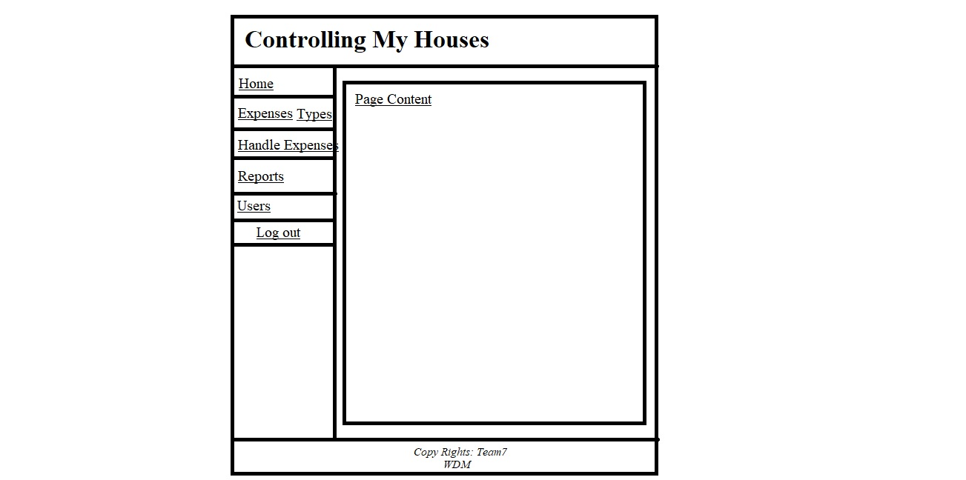

**Schema**

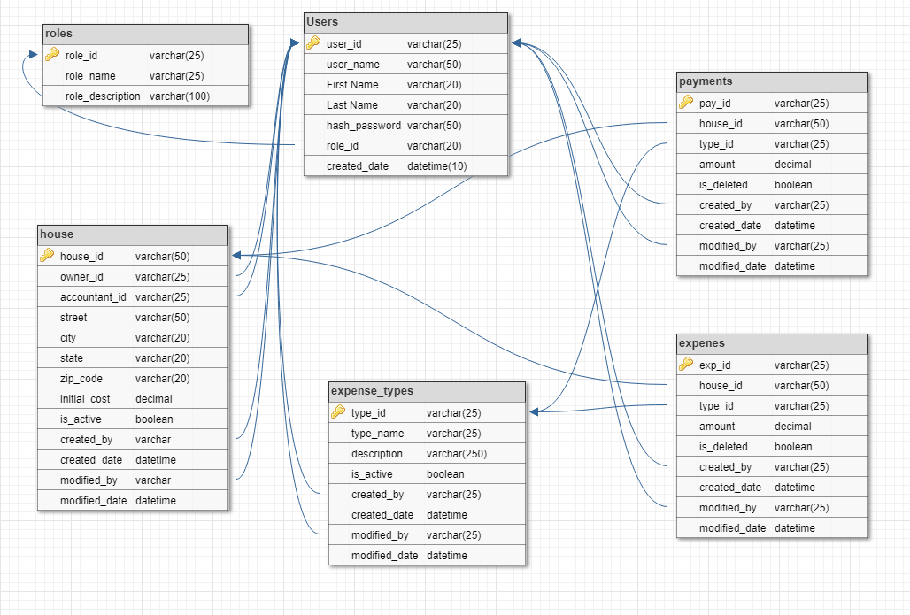

**Sample Data**

**Roles**

|  |  |  |
| --- | --- | --- |
| Role_id | Role_name | Role_description |
| =1 | **Admin** | **Admin Role** |
| 2 | **Owner** | **Owner of Hoses, adds houses** |
| 3 | **Accountant** | **Manages ecpenses** |

**Users**

|  |  |  |  |  |  |  |
| --- | --- | --- | --- | --- | --- | --- |
| User_id | User_name | First Name | Last Name | Hash_password | Role_id | Created_date |
| 1011 | **rxk2896** | **Rohit** | **Katta** | **Qdsdwd122#$@!(** | **2** | **3/4/2018** |
| 2022 | **Hxk496** | **Sajjad** | **Hashmani** | **Vdf!@)nSKD>?83** | **1** | **3/4/2108** |
| 3033 | **Sxk2356** | **Sanket** | **Kale** | **Dfjks#342r34><L** | **3** | **3/4/2018** |

**House**

|  |  |  |  |  |  |  |  |  |  |  |  |  |
| --- | --- | --- | --- | --- | --- | --- | --- | --- | --- | --- | --- | --- |
| House_id | Owner | Accountant | Street | City | State | Zip_code | Initaial_cost | Is_active | Created_by | Created_Date | Modified_by | Modified_date |
| H1 | **1011** | **3033** | **415 Summit Avenue** | **Arlington** | **TX** | **76013** | **$350,000** | **Y** | **1011** | **3/4/2018** |  |  |
| H2 | **1011** | **3033** | **300 W First St** | **Arlington** |  |  | **$850,000** | **Y** | **1011** | **3/4/2018** | **1011** | **3/4/2018** |

**Expense_types**

|  |  |  |  |  |  |  |  |
| --- | --- | --- | --- | --- | --- | --- | --- |
| Type_id | Type_name | Description | Is_active | Created_by | Created_date | Modified_by | Modified_date |
| T1 | **Tax** | **Tax Exp** | **Y** | **2022** | **3/4/2018** |  |  |
| T2 | **Maintenance** | **Maintenance** | **N** | **2022** | **3/4/2018** | **2022** | **3/4/2018** |

**Expenses**

|  |  |  |  |  |  |  |  |  |
| --- | --- | --- | --- | --- | --- | --- | --- | --- |
| Exp_id | House_id | Type_id | Amount | Is_Deleted | Created_by | Created_date | Modified_by | Modified_date |
| E1 | **H1** | **T1** | **300** | **N** | **3033** | **3/4/18** | **3033** | **3/4/18** |
| E2 | **H1** | **T2** | **250** | **N** | **3033** | **3/4/18** |  |  |

**Payments**

|  |  |  |  |  |  |  |  |  |
| --- | --- | --- | --- | --- | --- | --- | --- | --- |
| pay_id | House_id | Type_id | Amount | Is_Deleted | Created_by | Created_date | Modified_by | Modified_date |
| P1 | **H1** | **T1** | **300** | **N** | **3033** | **3/4/18** | **3033** | **3/4/18** |
| P2 | **H1** | **T2** | **250** | **N** | **3033** | **3/4/18** |  |  |

**GA3- SITE MAP**

* Login
* Home
* List of My Houses
* Edit House Details
* Add a new House
* Delete a House
* Handle Expenses related to the house
* Handle Expenses
* Add an expense for the house
* Delete an expense for the house
* Edit an expense for the house
* Expense Types
* Add an Expense Type
* Edit an Expense Type
* Delete an Expense Type
* Reports
* Net Profit/Loss calculated from total cost and expenses for all houses
* Net Profit/Loss calculated from total cost and expenses for the selected house
* Users
* Add a new user
* Edit the user
* Delete the user
* Payments
* Add payment
* Update Payment
* Delete Payment
* Logout

Group 7 GA1 meeting minutes

|  |  |
| --- | --- |
| Location:  Meeting called and recorded by | Central Library, Room No.315  Rutuja Nikam |
| Date: | 02/10/2018 |
| Time: | 4:00pm-6:00pm |
| Attendees: | Rutuja Nikam, Sajjad Hashmani, Ilwin Dcunha, Rohit Katta, Sanket Kale |

# Agenda items

1. Discuss the scope of the project No.7 Welcome to my House.
2. Discuss in detail all the functionalities of the project No.7 Welcome to my House.
3. Select the simple and intuitive UI design.
4. Divide the project documentation task equally.
5. Discuss the feasibility of each functionality from implementation point of view.

| Action items | Owner(s) | Deadline | Status |
| --- | --- | --- | --- |
| Discuss the scope of Project | All members | 02/11/2018 | Completed |
| Register houses functionality details | Ilwin Dcunha | 02/11/2018 | Completed |
| Manage Expenses functionality details | Rohit Katta | 02/11/2018 | Completed |
| Generate reports functionality details | Sajjad Hashmani | 02/11/2018 | Completed |
| Intuitive design selection | Sanket Kale | 02/11/2018 | Completed |
| Project description details  Feasibility of functionalities | All members  Rutuja Nikam | 02/11/2018  02/11/2018 | Completed  Completed |

Group 7 GA2 meeting minutes

|  |  |
| --- | --- |
| Location:  Meeting called and recorded by | Central Library, Room No.215  Sanket Kale |
| Date: | 03/03/2018 |
| Time: | 4:00pm-6:00pm |
| Attendees: | Rutuja Nikam, Sajjad Hashmani, Ilwin Dcunha, Rohit Katta, Sanket Kale |

# Agenda items

1. Discuss the database schema of the project No.7 Controlling my Houses.
2. Discuss in detail all the functionalities of the project.
3. Select the simple and intuitive Layout.
4. Divide the project documentation task equally.
5. Prepare URL structure that follows our navigation hierarchy.
6. Discuss the updates suggested by TA and incorporate all suggested changes.

| Action items | Owner(s) | Deadline | Status |
| --- | --- | --- | --- |
| Discuss the schema of Project | All members | 03/04/2018 | Completed |
| Prepare schema document | Rohit Katta | 03/04/2018 | In Progress |
| Update project description document | Rutuja Nikam | 03/04/2018 | Completed |
| Document functionalities | Ilwin Dcunha | 03/03/2018 | Completed |
| Intuitive Layout documentation | Sanket Kale | 03/04/2018 | Completed |
| URL structure preparation | Sajjad Hashmani | 03/04/2018 | In Progress |

Group 7 GA3 meeting minutes

|  |  |
| --- | --- |
| Location:  Meeting called and recorded by | Central Library, Room No.315  Rohit Katta |
| Date: | 04/07/2018 |
| Time: | 4:00pm-6:00pm |
| Attendees: | Rutuja Nikam, Sajjad Hashmani, Ilwin Dcunha, Rohit Katta, Sanket Kale |

# Agenda items

1. Creating the database using XAMPP and inserting data of the project No.7 Controlling my Houses.
2. Creating the base project for GA3 so that everyone will have same UI accessible.
3. Dividing the html page creation and the database creation among all the team members.
4. Discuss the suggestions given by the TA and inculcate them in current assignment.
5. Prepare the sitemap and other documentation.

| Action items | Owner(s) | Deadline | Status |
| --- | --- | --- | --- |
| Creating the database and inserting elements. Site Map creation and documentation | Rutuja Nikam | 04/08/2018 | Completed |
| Home page and add houses page creation | Sanket Kale | 04/08/2018 | Completed |
| Handle expenses and reports page creation | Rohit Katta | 04/08/2018 | In Progress |
| Login Page creation and validation | Ilwin Dcunha | 04/08/2018 | Completed |
| Expenses Type page creation and validation | Sajjad Hashmani | 03/04/2018 | In Progress |

Group 7 GA4 meeting minutes

|  |  |
| --- | --- |
| Location:  Meeting called and recorded by | Central Library, Room No.312  Ilwin D’cunha |
| Date: | 04/26/2018 |
| Time: | 4:00pm-6:00pm |
| Attendees: | Rutuja Nikam, Sajjad Hashmani, Ilwin Dcunha, Rohit Katta, Sanket Kale |

# Agenda items

1. Creating the base Code Ignitor project for GA4 so that everyone will have folder structure.
2. Dividing the modules so that everyone can start working on their module.
3. Discuss the suggestions given by the TA and inculcate them in current assignment.

| Action items | Owner(s) | Deadline | Status |
| --- | --- | --- | --- |
| Handle Expense Types module and add, edit, delete operations on it. | Rutuja Nikam | 04/29/2018 | Completed |
| Handle Expenses, Handle Payments and Houses and add, edit, delete operations on it. | Sanket Kale | 04/29/2018 | Completed |
| Handle Reports and Users module and operations on them. | Rohit Katta | 04/29/2018 | Completed |
| Login and Logout Module | Ilwin Dcunha | 04/29/2018 | Completed |
| Handle documentation and presentation | Sajjad Hashmani | 04/29/2018 | Completed |